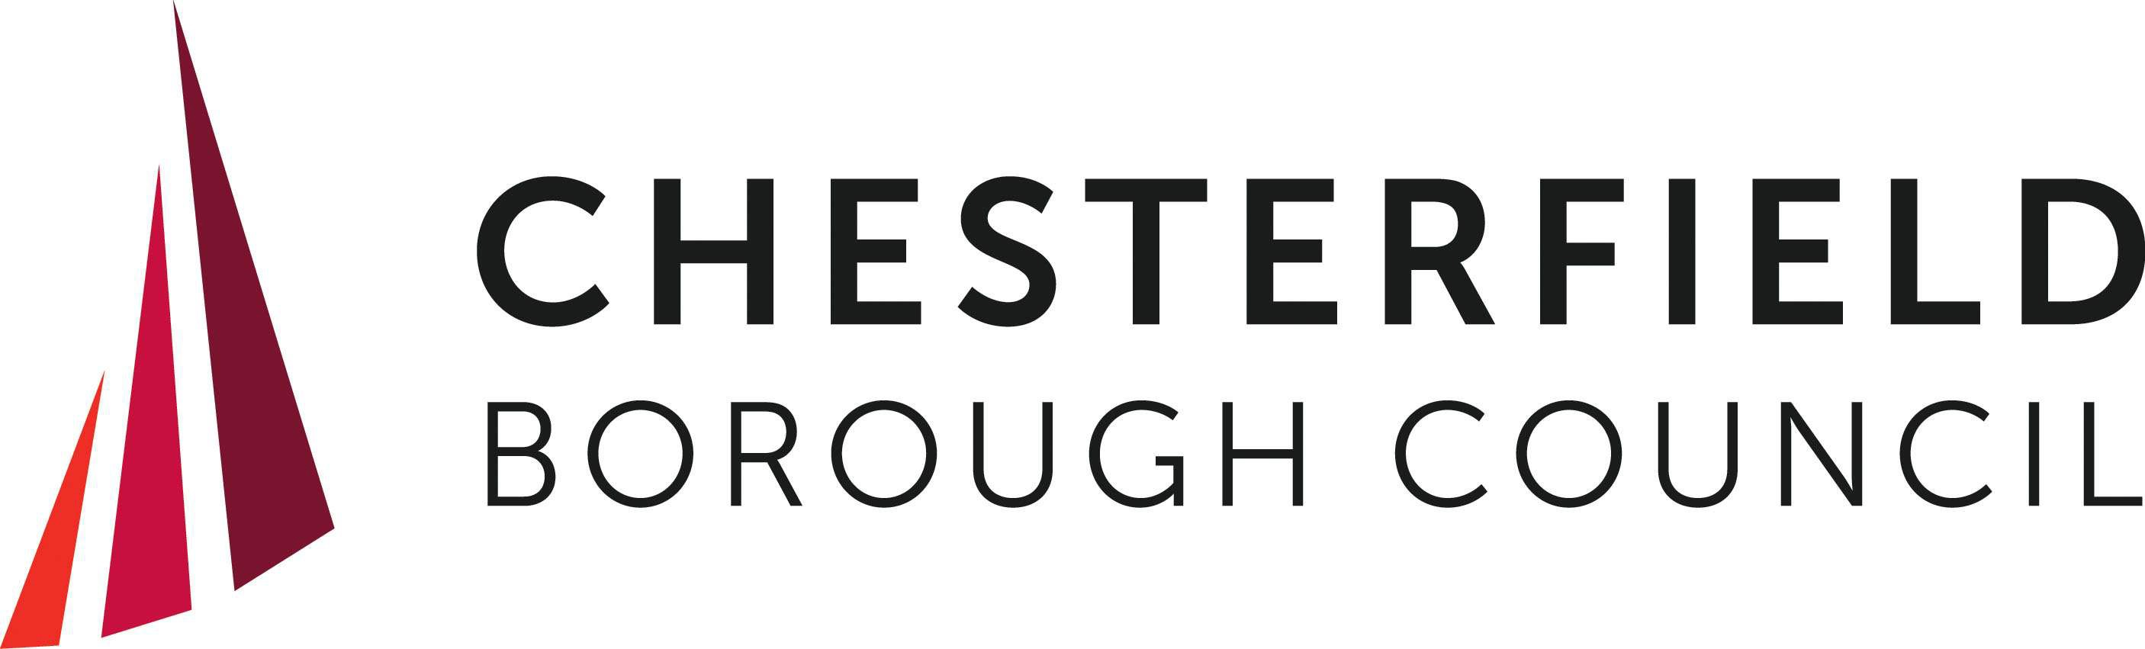

Chesterfield Borough Council Community Grants Fund Application Form
This is the application form for you to use to apply for Community Grants Fund. Ensure you have read the grant criteria before you start to complete this form.
All applicants must discuss their application with a Community Development Worker. This will help you to answer each question appropriately. The criteria can be found on our website: www.chesterfield.gov.uk/community-grants-fund
We would strongly encourage all applicants to discuss their application with a Community Development Worker and ensure you have read the grant criteria before you start to complete this form. This will help you to answer each question appropriately. The criteria can be found on our website: https://www.chesterfield.gov.uk/community-grants-fund
If you have any queries about completing the form please email communitygrants@chesterfield.gov.uk. Additional space is available at the end of the form if you need to provide additional information for any of the questions.
We will not hold records longer than 7 years from collection.
All information provided will be treated in accordance with the Data Protection Act 2018 and UK General Data Protection Regulation (GDPR). The data collected will be shared by Chesterfield Borough Council with the Community Grants Fund Commissioning Panel. All of the information you give will be treated as strictly confidential and will only be used for the purpose of assessing your application. None of the information you give will be passed on to any other agency or market research organisation. For contact details of our data protection officer, further information about how we use your data, or information about your data protection rights, please see www.chesterfield.gov.uk/privacy
As part of the Community Grants Fund process, applicants must ensure that they have read the grant criteria and discussed their application with a Community Development Worker before completing this form.
The criteria can be found here: https://www.chesterfield.gov.uk/community-grants-fund If you need to speak to a Community Development Worker, please email: communitygrants@chesterfield.gov.uk.
Have you discussed your application with a Community Development Worker?
 Yes No
Once you have discussed your application with the community development worker you will be provided with a reference number which will allow you to proceed with this application. Please provide the reference number below:

SECTION 1: APPLICANT INFORMATION
Organisation Name:
Lead Contact Name:

Contact Email Address:
Contact Telephone:

Address:
What kind of organisation are you?
 Charity
Community or voluntary group with a constitution
Social enterprise / Community Interest Company (CIC) Faith organisation/place of worship
If other – please state what type of organisation:

Please provide a summary of the service/activities normally delivered by your organisation (maximum words 100):

Please provide the current total balance of your organisation’s bank account (£):

Please briefly describe any restricted funds, reserves or large surpluses:

SECTION 2: SUMMARY OF THE PROJECT YOU ARE REQUESTING FUNDING FOR
Project name:

When is the project expected to start and finish? Start:
Finish:
Please describe the project you are requesting funding for (maximum 300 words):

Which of the following themes does your project contribute to:
Theme 1
 Strengthen the sense of local pride and belonging. Please provide further details:

Theme 2
 Build resilient, healthy, and safe neighbourhoods. Please provide further details:

Theme 3
Promote environmental sustainability / provide climate benefits. Please provide further details:

Theme 4
Develop volunteering opportunities / capacity building training. Please provide further details:

Theme 5
Enable community spaces and places for people to meet and engage e.g. community hubs / community gardens / parks / sports and activity facilities.
Please provide further details:

Theme 6
Provide events and activities that bring people together (that encourage greater social connections, reduce isolation, provide diversionary activities and bring people together from different groups).
Please provide further details:

Theme 7
Projects that promote social inclusion e.g. financial inclusion, better accessibility, addressing health inequality.
Please provide further details:

Theme 8
Projects that work in an area of higher levels of deprivation. Please provide further details:

Where will your project take place? Please be as specific as possible e.g name of community centre, venue, park (Scoring will be weighted in favour of projects within areas of deprivation - please see general assessment criteria, on page 14 of the guidance document for more information).
How do you know there is a need for your project?
(Have you researched existing services and activities? Are you aware of any gaps in services and activities? Have you obtained any community feedback from surveys or focus groups etc or letters of support?)
Who will benefit from the project? (Please describe the people or groups you intend to work with and why)

Are there any climate benefits or impacts of the project? See further notes in the funding guidance document in Appendix C.

SECTION 3: PROJECT BUDGET
Total project value (£):

Total Community Grants Fund requested in this application (£):

Expenditure, Outputs and Outcomes
Please complete a budget table below – this is a breakdown of what you intend to use the grant for. (Please put actual figures – not rounded up)

 | Item/activity: | Breakdown/details: | Amount (£):
1
2
3
4
5
6
7
8
9
10
Total
Please include your completed 'Additional budget and outputs information form' which can be found on the website: https://www.chesterfield.gov.uk/community-grants-fund when submitting this form.

Outputs and Outcomes

What outputs and outcomes do you expect to achieve?

Outputs: (i.e. what your project delivers e.g. number of sessions or participants)

Outcomes: (i.e. the positive changes that happen as a result of those activities)

Please explain how you will monitor and evaluate your project (e.g. attendance registers, pre and post data, focus groups and case studies etc.).

SECTION 4: TOTAL PROJECT FUNDING
If the total project costs more than the amount you are applying to the Community Grants Fund for, please explain how you will fund the remaining cost (Please note groups are able to apply for up to £6,000 for smaller projects, and up to £50,000 for large capital projects):

Please provide details of any existing / pending grants awarded for this project:

SECTION 5: CAPITAL PROJECTS - ONLY COMPLETE THIS SECTION IF YOUR PROJECT INCLUDES CAPITAL SPEND
Does your project include capital spend? (Capital funding can be used to purchase assets, either new or the significant refurbishment of existing assets. These are expected to have a wider community benefit and to have an expected lifespan of at least 5 years)
Yes No
Have you received planning permission to deliver your project?
Yes, granted
Yes, application in progress No
Not needed for the project
Who owns the property or land where the capital works will take place?

Have you received permission from the owner?
Yes No
Not applicable

Capital spend with the smaller grant or larger grant will require multiple quotes, depending on the amount of the item, as follows:
£0 - £5,000 – 1 quote is fine
£5,000 - £10,000 – we require 2 quotes
£10,000 - £50,000 – we need 3 quotes
Do you have the relevant quotes? (on receipt of your application we may ask to see them as applicable)
Yes No
Not applicable

SECTION 6: ALL PROJECTS

Does your organisation have a Safeguarding Policy?
Yes No

If yes, include a copy of your policy when submitting this form

Does your organisation have adequate insurance for equipment and activities?
Yes No

If yes, include a copy of your policy when submitting this form

If yes, please include a copy of your policy when submitting this form

If you would prefer to provide a link to your online constitution, please insert the link below:

Does your project involve working with vulnerable adults?
Yes No

Does your project involve working with children and young people under 18 years of age?
Yes No

Do all persons involved in the project have the appropriate level of DBS check? (if working with children and vulnerable adults)
Yes No  Not applicable

How will the project be sustained after the end of the Community Grants Funding (if applicable)? Please explain below:

If your project is associated with council land / property, have you discussed your project / application with the relevant Council service (e.g. Parks / housing / property services)?

Yes No  Not applicable

If yes, please provide the name of the person(s) you have been discussing your project with:

If you would like to include any additional information to support your application, please include it below:

ACKNOWLEDGEMENT
I confirm that the applying organisation is compliant with the conditions for the scheme and I am the authorised person to apply for this grant on behalf of the organisation. I also confirm that all of the information contained in this application is true and correct and I accept full responsibility for it.
I confirm the above (please tick)

