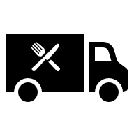
Insert Business Logo Here

Insert Business Name Here
Food Allergy Management Policy

Date of Preparation Day Month Year
Document Prepared by – Insert name



Table of Contents

INTRODUCTION 3
THE FOOD HYPERSENSITIVE CUSTOMER 4
The 14 Allergens 5
WHAT YOU NEED TO KNOW 6
WHAT FOOD ALLERGENS ARE CONTAINED IN WHAT DISHES? 7
UNDERSTANDING CROSS CONTAMINATION 8
HOW TO COMPLETE A FOOD SAFETY PLAN 9
FOOD ALLERGEN SAFETY PLAN 9
BUSINESS DETAILS 9
ALLERGEN PROCEDURES 10
MANAGEMENT 11
TRAINING 12
TAKING ORDERS 14
SUPPLIERS 15
STORAGE 17
LABELLING 18
CLEANING AND PERSONAL HYGIENE 19
PREPARATION, HANDLING and EQUIPMENT 21
PREPARATION, HANDLING and PLANNING 23
SERVICE – SELF SERVICE 24
SERVICE – SERVING 25
PRACTICAL IDEAS 26
QUICK REFERENCE CHECK LIST 28
MANAGING AN ALLERGIC REACTION…………………………………………………………………………………………………………….……..29
MORE ADVICE 30
SUGGESTED SIGNAGE 30
FOOD STANDARDS AGENCY 31
TRAINING 31
OTHER TRAINING …………………………………………………………………………………………………………………………………………….31
EXTRA RESOURCES….. ……………………………………………………………………………………………………………………………………..32
RECIPE CARD 33

INTRODUCTION

This pack was produced by Barnsley Metropolitan Borough Council, Food Safety Team, and updated by Chesterfield Borough Council in conjunction with Food Allergy Aware in 2026.

This pack is designed for small businesses wanting to adopt an allergen management policy tailored to their business needs – it is available in Word format and can be used as an update to a business’s existing methodology and processes.

This is a generic pack produced for all caterers/bakers; it may therefore not cover all the activities you undertake. If this is the case, you should alter the pack accordingly and add any extra safety points which are required for your business.

Thanks to the Food Standards Agency & Chartered Trading Standards Institute for their resources

Contact details for the contributors

Barnsley Metropolitan Borough Council – Food Safety Team

Tel: 01226 773743
Email: food@barnsley.gov.uk

Chesterfield Borough Council – Food Safety Team
Tel: 01246 345345
Email: food@chesterfield.gov.uk

Food Allergy Aware

https://foodallergyaware.co.uk/about-us-allergen-management





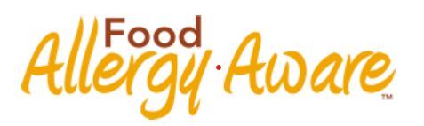

THE FOOD HYPERSENSITIVE CUSTOMER
Some people have food associated allergies, coeliac disease or food intolerances. For these individuals, exposure to certain foods can cause severe reactions and can even be life threatening. It is therefore essential that people suffering from food allergies, coeliac disease and food intolerances have access to the correct information involving the food they consume and are protected from accidental contamination.
- Food allergies involve the body’s immune system. The body reacts to certain allergens in food by producing antibodies and can affect different areas of the body at the same time. This can cause immediate and sometimes severe symptoms such as swollen lips or eyes, vomiting, skin hives and in the most extreme cases, difficulties breathing and a severe fall in blood pressure (anaphylactic shock). In extreme cases this can prove fatal.

- Anaphylaxis is a severe, potentially life-threatening allergic reaction that can occur within seconds to minutes after exposure to an allergen. It affects multiple body systems, including the respiratory, cardiovascular, gastrointestinal, and skin. Common triggers include foods like peanuts, milk, shellfish, and tree nuts; insect stings; certain medications; and latex. Symptoms of anaphylaxis include difficulty breathing, swelling of the throat, hives, low blood pressure, dizziness, and, in severe cases, loss of consciousness. Prompt treatment with an epinephrine injection is essential, as it can reverse symptoms and save lives. People with severe allergies are often advised to carry an epinephrine auto-injector (also known as an epi-pen) and should seek immediate medical help if they experience symptoms of anaphylaxis.

- Coeliac Disease is an auto immune disease, which affects some people when they eat foods containing gluten (Wheat, Rye, Barley & Oats). Gluten (a protein) affects the villi in the gut and prevents nutrients being absorbed by the body. Symptoms can include, gastrointestinal symptoms, such as nausea, vomiting, diarrhoea, weight loss, mouth ulcers, hair loss (alopecia) and skin rashes. Long term consumption can increase the risk of developing certain cancers.

- Food intolerances do not involve the immune system in the same way, and it is usually associated with difficulty digesting certain foods and having an unpleasant physical reaction to them. Symptoms usually take longer and may include headaches, fatigue and digestive problems. Food intolerances are harder to diagnose than a food allergy.

- Summary: When preparing food do not differentiate between food allergies, coeliac disease or intolerances. To the sufferer, the effects of each of these conditions can be very serious.
The (Insert name of Food Business Operator) adheres to the Food Information for Consumers Regulations 1169/2011 which was introduced in 2014. The operator has set out this Allergen Management Policy and Standard Operating Procedures based to ensure the protection of staff and customers throughout the food preparation and supply and to reduce the risk of unintentional food contamination.
The operator should make sure that ALL staff working within the food preparation and service areas are aware of the procedures and ALL staff should implement the procedures to ensure the safety of ALL customers and staff.

The 14 Allergens

These are the 14 allergens that you must know about. You must know if any of these allergens are in any of the foods you make or serve.

Consumers may ask about other ingredients, but these are the ones you have a legal obligation to know if they are in the foods that you make/serve.

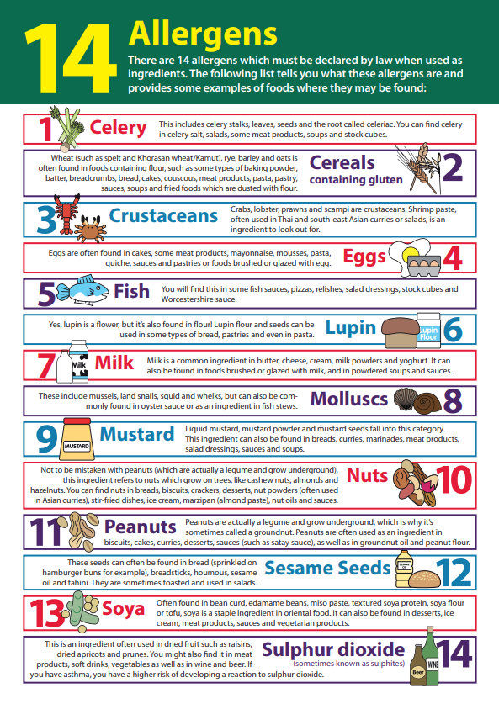

A copy of this sign can be accessed here click here. It is also available in a number of other languages which can be accessed here https://www.tradingstandards.uk/practitioners/food-allergen-resource/

It is recommended that a copy of the poster in an appropriate language is displayed in all food preparations areas.

WHAT YOU NEED TO KNOW

It is not enough for businesses to say that they do not know whether or not a food contains an allergen, nor is it enough to say that all their foods may contain allergens. Allergen information must be specific to the food, complete and accurate.

As a food business operator, you must provide specific allergen information on foods served. You cannot give incorrect or misleading information on a menu or through verbal communication.

The allergen information can be supplied on the menu, on chalk boards, tickets or provided verbally by an appropriate member of staff. It must be clear and conspicuous, not hidden away, easily visible, and legible.

If the information is to be provided verbally by a member of staff, then it is necessary to make this clear by means of a notice, on the menu, ticket or label.

Signage

You must display a sign near to the point of order or have a notice on the menu requesting that customers inform you if they have a food allergy, coeliac disease or food intolerance.

The example produced by the FSA is shown below can be used and is available to download here https://www.food.gov.uk/sites/default/files/media/document/Allergen%20and%20Intolerance%20sign%20%28Colour%29.pdf or you can design one of your own with your food business’s appropriate wording.

An example of appropriate wording:

If you have a Food Allergy, coeliac disease or food intolerances: Please ask a member of staff if you require information on the ingredients in the food we serve

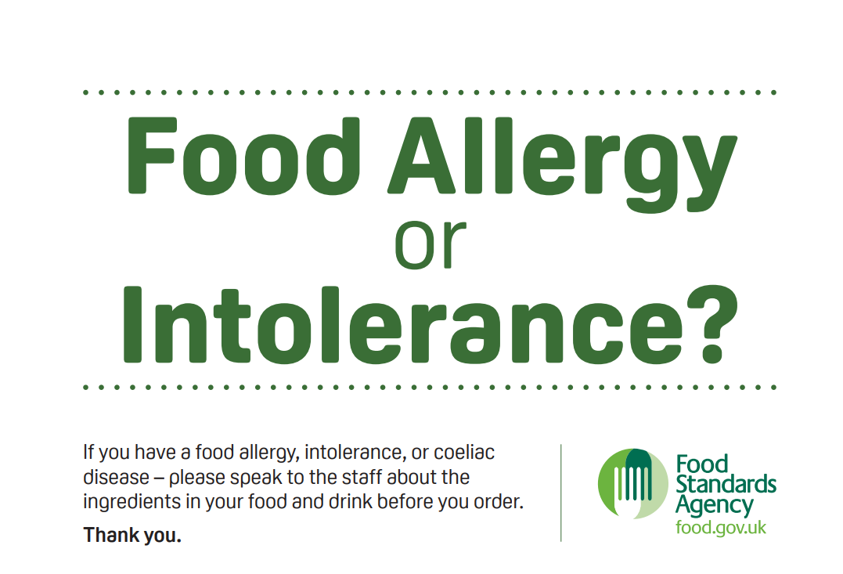

WHAT FOOD ALLERGENS ARE CONTAINED IN WHAT DISHES?

Look at the label
You need to know what allergens are in all of the dishes and open food you sell. To do this you must find the ingredients list on all packets of food, including ingredients used in dishes.

Contact your Supplier
If you buy open food from a supplier e.g. bread, cakes, pies etc., you must ask the supplier to provide you with the allergen information for these products.

Keep the information
You can save the labels from the packets of food which contain allergen information and or transfer this information on to an allergen matrix. Whatever method you choose, you must ensure the information is easily retrievable and up to date. I.e. regularly check for recipe/product changes.

Use the above information to collate ingredients within your recipes, it is important to have a
standard recipe and keep ingredients from the same brands to ensure consistency of your products.
If you change brands or have a substitution, check labelling for additional allergens.

May Contains – Precautionary Allergen Information (PAL)

Food businesses may voluntarily use labelling such as ‘produced in a kitchen which uses…’ or
‘may contain…’ or ‘not suitable for.’

• These statements are used to communicate the risk of the unintentional presence of an
allergen (e.g., milk, egg, peanuts, almonds) in a food product.

• This is typically due to the allergen entering the product accidentally, or through cross
contamination.

• These statements should only be used after a meaningful risk assessment has been
performed and there is a significant risk to the food allergic (or intolerant) consumer.

• These statements should not be used as a substitute for good hygiene and safety practices
or as a catch all to avoid risk assessment.

If you are making products and/or meals, you can either complete the allergen matrix or use a recipe card to record the allergens. This may be easier if you are using a number of ingredients/constituents. Two versions are shown below. Remember to check all ingredients used, including those used for sauces, thickeners or garnishes and the oil used to fry products in.

Allergen Matrix | Recipe Card | Recipe Card
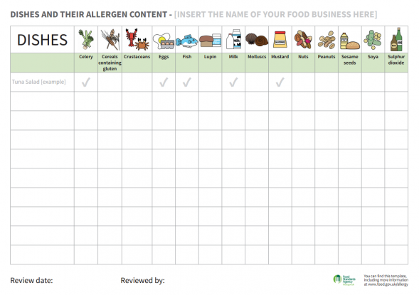 | 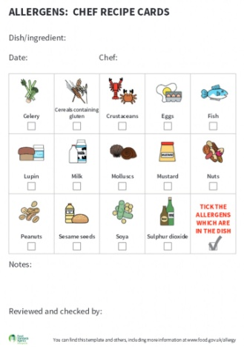
  Menu Item:
  Ingredients | Contains
   | 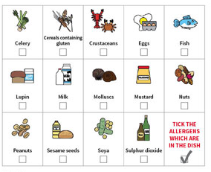
   | Notes/Special Requirements:
  Date Completed | Notes/Special Requirements:
  Name | Notes/Special Requirements:
  Date(s) reviewed | Notes/Special Requirements:
  Name | Notes/Special Requirements:

Once you have identified what foods/dishes contain what allergens, you must keep this information up to date. E.g. If you change products, suppliers or your menu.

All staff must know where this information is kept, in case they need to answer a query about allergens in your products or meals

UNDERSTANDING CROSS CONTAMINATION

Once you have identified allergens contained in your food, you must consider how you control these allergens and prevent any cross contamination between allergenic foods/ingredients and non-allergenic foods/ingredients. This guide will help you assess what allergenic foods you have and allow you to determine if you can control allergens in your premises.

This will then allow you to:

- Assess whether the controls you have in place are sufficient to provide allergen free food safely.
- Identify if improvements can be made to your systems, so allowing you to make allergen free food safely.
- Allow you to decide you cannot make allergen free foods safely and therefore not offer them.

If you want to provide allergen free foods you must have a management system in place, to show how this can be achieved. This can be undertaken by completing, implementing and training your staff in the safety points contained in this guide.

If you are not completely certain that you can provide food that is suitable for someone with a food allergy/hypersensitivity, then you must tell them, so that they can then decide if they want to eat the foods you provide.

If you tell a customer that you cannot guarantee a meal is free from a specific allergen but agree to serve them a meal – you must still ensure that the meal is prepared safely, applying the principles of hygiene given in this guidance.

HOW TO COMPLETE A FOOD SAFETY PLAN

All food businesses must have a suitable food safety management system in place. If you wish to provide allergen free foods, your documented food safety management system must show how the food produced is safe to consume and free from the specified allergens.

This can be undertaken by completing, implementing and training your staff on the safety points contained in this guide. Look at each safety point in turn and complete the right hand column to explain how you, as the business operator, ensure that the food you produce is safe.

BUSINESS DETAILS

Name of Business

Address
from which the business ordinarily operates:

Name of business owner/food business operator:

Will you be preparing/offering allergen free food?

If yes -
What allergens are you able to eliminate and provide a ‘free from’ food for?
If no -
Have you displayed the appropriate signage ?

Review Dates:
(This document should be reviewed each year and amended where necessary, particularly if you start a new product or try new methods of preparation)
Review date | Reason and amendments made |  | Staff informed  (Yes/No)

ALLERGEN PROCEDURES
Preparation & Cooking
What could go wrong?
- Cross-contamination between allergens and other prepared foods via shared utensils, equipment or food handler.
- Trace allergens are passed through the hand contact of the food handler.
- Chef adds replacement / additional ingredient to the recipe
CONTROLS
- Work surfaces must be cleaned using the two stage cleaning process before preparation of an allergen- free meal.
- Foods are always prepared to the standard recipe – no additional ingredients are to be added.
- Allergen containing foods are positioned in the kitchen so accidental spillage will not result in product contamination.
- Spoons are not left in allergenic foods.
- Decanting spoons, ladles and tongs are single use for allergenic ingredients.
- Separate utensils are available for preparation of allergen-free orders. These are kept in a separate sealed container and used solely for preparing GF orders.
- When preparing a meal for the FHS customer, ingredients should be taken from fresh containers in the fridge and not from a container containing ready prepared ingredients. This may include GF cakes which may normally be on display.
- Allergenic ingredients are never removed from a dish and served to a customer with a food allergy. The meal must be made to order with fresh ingredients.
- Food handlers must wash their hands prior to the preparation of a meal for specific dietary requirements.
- Separate equipment including fryers and pizza trays are to be used for the cooking of GF items.
- GF sandwiches are prepared using a purple knife and board which are stored separately
- Oil in deep fat fryers previously used to fry allergen containing foods, must not be used. A separate deep fat fryer and basket should be available and used ONLY for GF requests. Signage must be in place at or on the equipment so that all staff are aware.
- Where prepacked free-from foods are cooked on site, a different oil must be used to prevent cross contamination between products.
- Colour coded milk jugs and cloths are used when making hot drinks and signage is clearly displayed COW’S MILK = GREEN OAT MILK= YELLOW SOYA MILK = BLUE

CORRECTIVE ACTION / MONITORING
- Visual checks on allergen signage and preparation methods
- Re- training of staff
- Questioning staff on free-from food preparation/cooking methods

SAFETY POINT: MANAGEMENT

Control | What do you do
You must know if any of the 14 specified allergens are in any of the dishes/ open food you sell. | How do you record your allergen information?  Where do you store this information?
  Matrix/table
  Recipe card
  On the menu
  Save labels
  Verbal
  Other: please state
You must display notices advising customers to ask for information on allergens or signpost them to where this information is displayed.  Allergen information could be contained in menus to assist customers choosing meals.  You could also place allergen information on your website. | Where are these notices displayed in your premises?  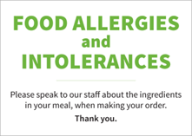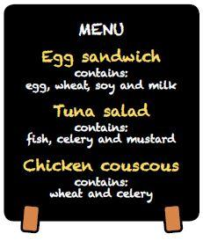
All staff, including managers, food handlers, service staff and staff taking orders in person or over the phone etc., must be aware of the risks posed by allergens and of providing wrong information to customers.  Notices can be downloaded from:  https://www.food.gov.uk/sites/default/files/media/document/thinkallergy.pdf | Display notices reminding staff of the risk  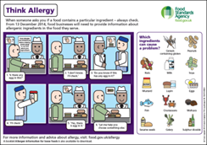
If kitchen staff make recipe changes they must update the allergen information and tell front of house staff. | How do you update information?  Who will tell staff

SAFETY POINT: TRAINING

Control | What do you do
Train ALL your staff in allergy awareness. | Training should include the following:  - Educate staff on the physical effect of providing the wrong information or serving food containing an ingredient that a customer is allergic to.  - Legal obligations of keeping a FHS customer safe.  - Have in place procedures to prevent cross-contamination during storage, from delivery to preparation, cooking and service of food.  - Identify customers with food allergies when they book a table, or when staff take orders (e.g. menu reminders).  Always ask if someone has a food allergy at all stages of the customer contact from booking to ordering.  - Consider providing a checklist or guidance that staff can refer to whilst taking orders that highlights which dishes contain what type of allergenic ingredient.  - Have a system for informing kitchen staff that the food they are to prepare is for somebody who is allergic to certain ingredients.  - Have a procedure for dealing responsibly with a customer complaint / feedback over concerns that their food may be contaminated with an allergenic ingredient or a mistake that has occurred. Staff should not just remove the ‘offending’ allergen from a prepared dish and send it back on the same plate, because traces of the allergen will remain which could cause a reaction.  See near miss reporting
Make sure that all staff understand that they should never guess whether or not an allergen is present in food. Always be honest with the customer. If you do not know, say so

Allergen awareness training is freely available online at:
https://www.food.gov.uk/business-guidance/allergy-training-for-food-businesses

It is good practice that this is undertaken by food handlers. There is no cost for this training.

The Chartered Trading Standards Institute offer free
resources in multiple languages, training video,
posters (see above) page and resource handout –
review for your staff where English is not the first
language.
https://www.tradingstandards.uk/practitioners/foodallergen-resource
Staff should receive general allergen awareness training and training in your own allergen control procedures.

Have all kitchen staff received food allergen awareness training?

Yes/No

Have front of house staff (bar staff, service staff, staff taking order over the phone, in person etc.) received food allergen awareness training?

Yes/ No

It is good practice to ensure all training given to staff is recorded and kept on file and that refresher training is given on a regular basis.

This can be recorded in the table below and or in your SFBB pack in the training section.

Allergen Training Record

Staff Member | Position | Training Received | Date

SAFETY POINT: TAKING ORDERS

Control | What do you do
When a request is received about an allergy, you must have procedures in place to provide the correct information  - Who can deal with the request?  - Are they trained in allergens?  - Where is the information stored on allergens present in your meals?  - Consider providing a checklist or guidance that staff can refer to when taking orders, that highlights which dishes contain what type of allergenic ingredients.  - How are the kitchen staff told that the food they are about to prepare is for somebody who is allergic to an ingredient? | Name/s:  What training have they received?  Where?  The check list should clearly show which allergens are in each food/meal.  Explain how you do this?
To assist with planning in the kitchen, for group and advanced bookings, ask your customers if they suffer from any food allergies, and identify any dishes that they will not be able to eat.  Ask customers who require meals free from an allergen to order in advance. | Do you do this?
You must deal responsibly with a customer complaint over concerns that their food may be contaminated with an allergenic ingredient. Staff should not just remove the ‘offending’ allergen from a prepared dish and send it back on the same plate, because traces of the allergen will remain which could cause a reaction | What do you do if a customer complains that their meal may contain an allergen?

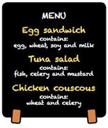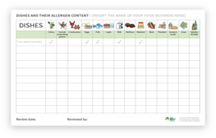

SAFETY POINT: SUPPLIERS

Control | What do you do
You must have allergen information from all your suppliers; this may be data sheets, downloads or labels for pre packed foods or on a sheet for loose/open foods E.g. if you get open pies/pasties, sausages etc. from a butchers.  Note: It is not sufficient to supply allergen  information only ALL suppliers are obliged to  provide full ingredient information, no matter  the size of their business | Check that all food you receive has been supplied with allergen information and complete the table below.
Do you choose or are you given substituted items, if the item you want is not in stock or another product is cheaper etc.?  If Yes,  You must check the allergen information on this product, to see if it is different from your regular product.  If this information has changed, you must record this and advise staff members. | Where do you record it?  And how do you advise staff members?
Ensure all labels are in English: you must be able to read all your labels. | 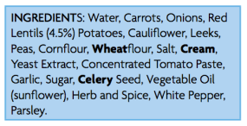
You must check for any changes on the products you buy in on a regular basis e.g. when it says 'new recipe'? This must be done each time you buy a product.  If this information is changed, you must record this and advise staff members. | Where do you record it? And how do you advise staff members?

Allergen Information Received from Suppliers
Supplier | Food Supplied | Allergen Information Supplied: Yes/No

SAFETY POINT: STORAGE

Control | What do you do
A storage system must be in place to prevent the cross contamination of ingredients with other ingredients containing allergens. | Consider the following control points and implement an adequate control system
You should ideally store ingredients containing allergens in a separate area.  Or, if this is not possible you must  Store allergen free items on an upper shelf.  This applies to all storage, dry, wet, chilled and frozen. | What do you do?
If any ingredients are decanted into separate containers for storage, you must do the following:  - Transfer all the product information including allergens to the container. Ideally place the product still in its original bag into the container. If you cannot do this use the stickers shown in the storage section to transfer the information over  - Containers must be airtight to prevent cross contamination between products e.g. powders, grains etc.  - Ideally containers must only be used for the named allergen.  - If however you have to change designated containers, you must thoroughly wash them before use.  - You must dispose of heavily scoured containers, as they cannot be thoroughly cleaned.  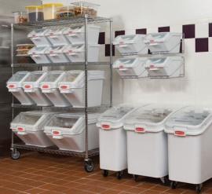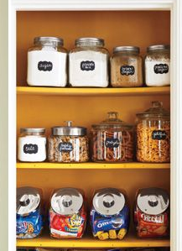 | What do you do?

LABELLING

Control | What do you do
You must label ingredients/products produced with their allergen contents. You can do this by:  - Using colour code system to identify ingredients containing allergens.  - Keeping original allergen labelling information with each product.  - Labelling with allergen information, this can be done using stickers. These can be obtained from most wholesalers/ catering suppliers.  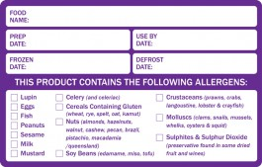  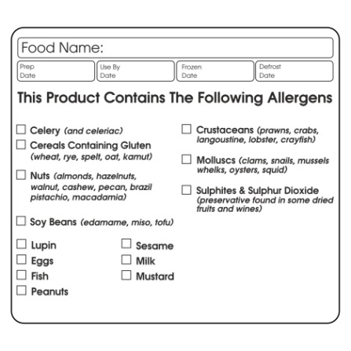  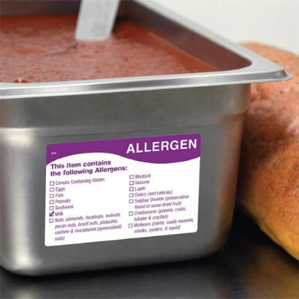 | What do you do?

SAFETY POINT: CLEANING AND PERSONAL HYGIENE

Control | What do you do
Hands must be washed before handling and
preparing and allergen free meal.
Thorough cleaning must take place in the preparation area before handling and preparing foods which are free from an allergen.  You should use the two-stage cleaning process.  Hot soapy water, designated disposable cloths or blue roll to remove allergens and sanitiser as per manufacturer’s instructions once you are sure all allergens are removed, to prevent cross  contamination through cleaning equipment. | What do you do and use?
You must have a spillage plan in place to clean up allergenic ingredients: You should use disposable cloths or blue roll, so preventing cross contamination. | What do you do?
Food handlers must wear suitable protective clothing when preparing an allergen free meal,  Provide food handlers with disposable aprons/designated washable aprons to wear when preparing an allergen free from meal. | What personal protective clothing is worn when preparing a free from meal?
Designate one person to be responsible for preparing allergen free meals.  This is to ensure that no cross contamination can occur between foods containing allergens and foods which are allergen free.  E.g. kitchen staff preparing shellfish may get their clothes contaminated with these food residues and move on to prepare a shellfish free meal and can contaminate it. | Who is this?
All food handlers and serving staff must be trained in the importance of handwashing in preventing cross contamination, due to hands playing a major role in allergen cross contamination  Train all food handlers in adequate hand washing procedures.  Hands must be washed before handling and preparing and allergen free meal. | 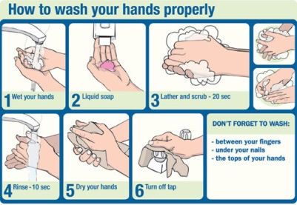
An example cleaning schedule is available in the Safer Food Better Business pack. It can also be downloaded here.  https://www.food.gov.uk/sites/default/files/media/document/cleaning-schedule.pdf | 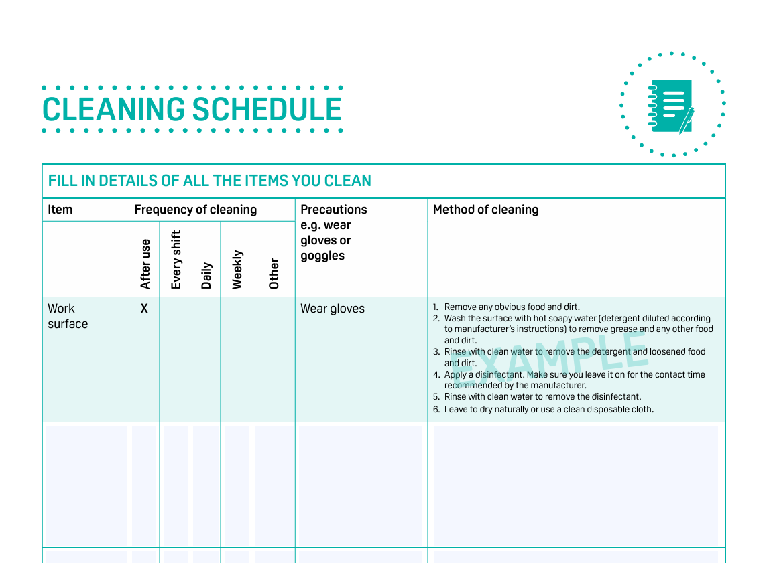

SAFETY POINT: PREPARATION, HANDLING and EQUIPMENT

Control | What do you do
Procedures must be in place to prevent cross contamination when preparing food for a customer with a food allergy. | Consider the control points and implement an adequate control system.
Check ingredient labelling for allergenic ingredients.  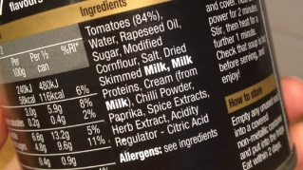 | Allergens will be emphasised on the label in the ingredients section in bold.
You must ideally prepare a free from food in a separate designated area, with separate equipment. E.g. colour coded equipment.  If this is not possible could you prepare them at a different time e.g. in advance and thoroughly clean down the area before use?  This is to stop cross contamination occurring between foods containing allergens and foods which are allergen free. Some allergenic ingredients e.g. sesame seeds are easily spread around the kitchen and need extra care. It is best to use a separate room. | What do you do?
Use designated separate equipment and utensils.  If this is not possible, thoroughly clean equipment/ utensils/ surfaces between uses.  HOWEVER  In instances of hard to clean equipment/ utensils, you must have separate equipment/utensils. examples include:  - Woks are very hard to clean food residues from after cooking e.g. traces of egg from egg fried rice and fish.  - Milk steamers on a coffee machine, may have dairy residues in the spout.  - Mixers for making batter or cakes, residues may be difficult to remove from mixer heads.  - Cooking oil cannot be reused for frying food for a person with an allergy, once it has been used for food containing allergens. | Do you have separate equipment?  What equipment?  How is it distinguishable?  Do you have a separate wok?  Do you have separate steamers?  Do you have different mixers?  Do you have a separate fryer?

PREPARATION, HANDLING and PLANNING

Control | What do you do?
Garnishes, drizzling oils, sesame seeds, dessert toppings, nuts etc. can also contain allergenic ingredients. Staff must be aware of their contents. | Are these covered in your allergenic assessments?  Are serving staff aware of them?
The preparation and service of cakes and desserts may not be done by kitchen staff, but by service staff. Ensure all staff are fully aware of allergen controls. Use separate equipment and utensils for service. | Are these covered in your allergic assessments?  Who serves these, what controls are in place?
Consider revising menus and or recipes to exclude some /all allergenic ingredients, so removing some allergenic ingredients from dishes and so possibly completely removing them from the kitchen

Could some recipes be revised to be allergen free alternatives, which could be made in advance and stored safely? So preventing the need to prepare allergen free meals during a busy kitchen service period.  E.g. gluten free pastry, scones, muffins, tarts, pies. etc. | Do you do this? If so:  When do you prepare them?
If foods such as casseroles, pies, fruit tarts, scones etc. containing allergens are batch cooked, cooled and or stored with ones not containing allergens, how are the different varieties identified? | How do you identify the allergen free foods?
Serving Foods – Avoid serving foods on wooden boards (even with paper) baskets as  they harbour allergens – serve on plates,  different shape or with an allergy label or flag | How do you serve your food?

SAFETY POINT: SERVICE – SELF SERVICE

Control | What do you do?
Consider the storage of products on display, e.g. in serve over counters. (Ambient, chilled and frozen).  - Ensure desserts and other foods e.g. Cakes, tarts, gateaux, ice creams and toppings containing allergenic ingredients e.g. nuts, are stored separately in the display units.  - They must be adequately separated and have clearly distinguishable display plates and service utensils e.g. colour code.  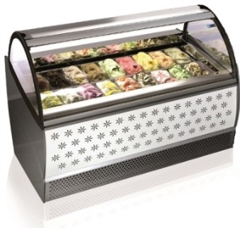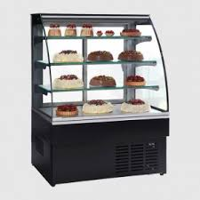  Do not store allergen containing food above allergen free foods. | How do you display and serve your allergen free food?
At self-service counters e.g. salad bars, buffets, carveries etc:  - There must be adequate signage providing customers with details of the foods and their allergenic contents.  - Foods containing no allergenic ingredients must be sufficiently separated and easily distinguishable from food containing allergenic ingredients and displayed in a way to prevent any falling food contaminating it.  - Provide sufficient utensils to prevent cross contamination. Are they easily distinguishable? | Do you have a self-service counter?  How do you do this?  How do you do this?  How do you do this? And how do you make sure the utensils do not get mixed up?
Do you sell Prepacked for Direct Sale PPDS foods? Foods made and wrapped in packaging  on the premises – These need have full  ingredients and allergens highlighted – check  the FSA website for full details | Do you have PPDS products?

SAFETY POINT: SERVICE – SERVING

Control | What do you do?
Ensure that the allergen free meal is given to the correct customer.  - The person who made the meal could take it out.  or  - The person taking the order could take it out.  or  - A manager or allergy guru could deliver  When serving the meal/ handing over a takeaway, always double check that they are the customer who has ordered the allergen free meal and state what food is free from!   | How do you ensure this happens?
Where food is delivered/ given as a takeaway, ensure the box/packaging is clearly labelled.  If an allergen free meal is being delivered with meals containing allergens, place the free from meal in a separate bag, to prevent any cross contamination through leaking containers.  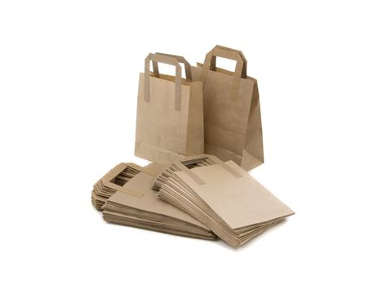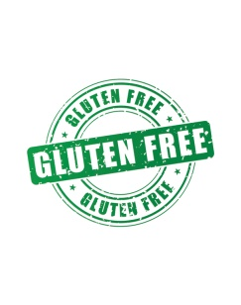  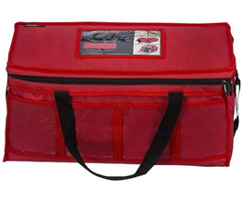 | How do you do this? Is it on the website pre-post ordering? Labels for the packaging?

PRACTICAL IDEAS

Consider adding allergenic ingredients at the end of the dishes preparation.

e.g. In businesses offering rice, egg free rice can easily be offered by using a rice cooker to just prepare boiled rice, with egg fried rice stored in a separate rice cooker or made to order.

In pizza/sandwich/ cafes etc. gluten free dough/bread could be bought in, stored separately and safely to avoid cross contamination and baked/toasted on grease proof paper under a grill which is disposed of, or use designated trays or toastie bags. Therefore, preventing cross contamination by dual use of equipment.

Allergen free meals could be bought in from a reputable supplier, stored safely in a designated allergen free area e.g. fridge/freezer and reheated to order, applying safe allergen hygiene procedures.

Cooking oil cannot be reused for frying food for a person with an allergy, once it has been used for food containing allergens.

For example, premises offering gluten free fish and chips will need to have a separate designated fryer. E.g. a table top fryer, which is clearly signposted gluten free, as the frying oil in the main fryers will be contaminated with gluten from the batter mix.

The gluten free batter mix must also be made in a separate bowl with a separate whisk.

Ensure the food handler has a disposable/separate apron on and has washed their hands before preparing the batter.
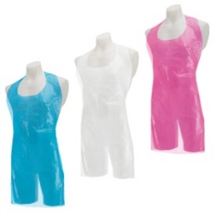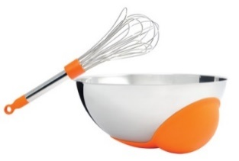
Food Probes and wipes: Ensure you have a  process in place when using food probes to  check allergen free meals and that they are  cleaned and wiped every time of using them | Probes process in place?

QUICK REFERENCE CHECK LIST

This list can be used as a quick reference check sheet for preparing a free from meal. You could have this displayed in the kitchen where you prepare an allergen free food as a reminder to staff, and or you could complete it each time you prepare an allergen free meal. If you have additional steps, please add them in.

Note: this quick reference list does NOT replace your management system, but acts a practical quick reference guide.

Stage |  | Completed
1 | The allergen is to be recorded on the order and the person taking the order must speak to the chef directly confirming this.
2 | Have at least one pan set aside that is never used for fish, prawns or any other crustacea.
3 | In the case of persons with a mustard or celery allergy; the pre-mixed curry spice must not be used.
4 | The chef or a designated cook will prepare the meal separately from any other meals.
5 | Set aside a specific work area to prepare the meal. Clean it with hot soapy water and rinse it off.
6 | Clean all required equipment utensils and pans, including serving dishes and plates with hot soapy water and rinse off. Then sanitise as per instructions on  the bottle
7 | Clean hands with soap and hot running water and rinse to remove allergen traces from other food that has been handled.
8 | Set out required ingredients on the workspace. Use only ingredients that have been kept in sealed or lidded containers, dedicated for that product. Scoop out using a clean spoon or measure.
9 | Use only fresh oil / ghee for frying. (Re-used oil may be contaminated.)
10 | Unless it is to be served immediately, cover to protect from contamination.
11 | Either the chef / cook will take the prepared meal to the customer, or he will pass it to the person who took the order to serve directly to the customer.

Managing an Allergic Reaction

Reporting
If a of a food allergy, intolerance or coeliac reaction incident or near miss occurs it is important that you have a reporting procedure in place and investigate what happened. This will help you to prevent a similar occurrence happening again in the future and to identify any trends in incidents. All staff members should be encouraged to report any incidents.
You should:
- Record what happened e.g. incorrect allergen information provider to the customer, customer having an allergic reaction after being provided with a meal they believed did not contain a particular allergen.
- Why it happened e.g. staff not trained, unaware of a change to ingredients in a product, customer allergy information not passed onto the food preparation staff, cross contamination.
- What changes need to be made to made e.g. amend procedure for providing allergen information to customers, re-train staff, increase frequency of updating allergen matrix, review procedure for providing allergen information to food preparation staff.
- Communicate the outcome of any investigation to all relevant team members.
- Implement and monitor the required changes

You may wish to undertake a Root Cause Analysis to help with your investigation and to determine how and why the problem occurred. Links to more information about Root Cause Analysis and a free training course are provided below.
Bing Videos
Food Standards Agency - Root Cause Analysis
RIDDOR Reporting
Dependant upon the circumstances it may be necessary for a RIDDOR report to be submitted. More information can be found here https://www.hse.gov.uk/riddor/reporting/index.htm
What to do if a Customer Experiences and Allergic Reaction at Your Premises
The NHS provides information on what you should do if someone is experiencing an allergic reaction. It can be accessed here https://www.nhs.uk/conditions/anaphylaxis/
It is recommended that all staff are aware of this information.

MORE ADVICE

If you have completed this assessment and feel that your business needs more advice, please contact Chesterfield Borough Council, Food Safety Team on Food@chesterfield.gov.uk

SUGGESTED SIGNAGE

If you have considered the controls required and you are not completely certain that you can provide food that is suitable for someone with a food allergy, then you must tell them, so that they can then decide if they want to eat the foods you provide. You can display a sign saying this.

We have carried out a risk assessment of our kitchen procedures and although we have taken steps to control the unintended presence of allergenic ingredients in our food, due to the nature and size of our kitchen we cannot fully guarantee a safe meal. Please speak to a member of our management team for more information

Or you may decide that you can provide free from options for one or a few of the allergens, as there is no legal obligation to provide food free from all of the allergens. For example, you can cater for gluten free customers by having a small supply of gluten free ready meals on site.

However, you must be able to identify which of the 14 allergens are contained in your food.

FOOD STANDARDS AGENCY

TRAINING

Free online allergen awareness training is available at the Food Standards Agency Website

FSA https://allergytraining.food.gov.uk/
More information can also be found on the Food Standards Agency Website

- https://www.food.gov.uk/business-industry/allergy-guide

Resources and video training in the following languages can be found by clicking the link
https://www.tradingstandards.uk/practitioners/food-allergen-resource/ , these include
- Link to full allergen awareness training video
- Poster
- Resource handout

English  Welsh  Bengali  Cantonese | Kurdish Mandarin  Punjab  Turkish | Urdu  Bulgarian  Hungarian Polish  Romanian

Other Training

- Wakefield Council have produced a training tool focussing on Precautionary Allergen Training (PAL). It can be found here AllergyPAL | Your Allergen Training Tool
EXTRA RESOURCES
More information can also be found on the Food Standard’s Agency Website
A number of resources and sources of information can be down loaded from the Food Standard’s Agency Website, including:
Allergen information for loose foods guidance leaflet can be found on the Food Standard’s Agency Website. This leaflet was developed in collaboration with food industry and consumer support organisations. | 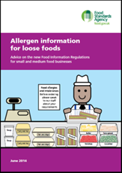 | https://studylib.net/doc/8167201/allergen-information-for-loose-foods
Think Allergens Poster; a quick glance reminder to staff of the importance of allergens.  This has also been translated into four Asian languages Urdu, Punjabi and Bengali as well as simplified Chinese |  | https://www.food.gov.uk/sites/default/files/media/document/thinkallergy.pdf
Allergen information for pre-packed and  loose foods |  | https://www.food.gov.uk/print/pdf/node/164
Allergen Signage; upfront signpost to direct customers on where and how to obtain allergen information. | 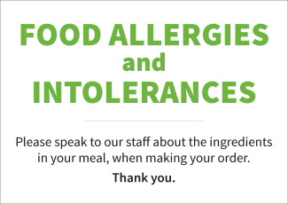 | https://www.food.gov.uk/sites/default/files/media/document/Allergen%20and%20Intolerance%20sign%20%28Colour%29.pdf
Chefs Recipe Cards | 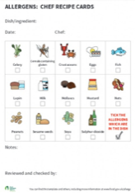 | https://www.food.gov.uk/sites/default/files/media/document/recipe-sheet_0.pdf
Allergen Table | 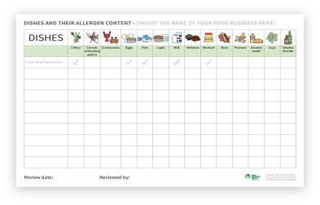 | https://www.food.gov.uk/sites/default/files/media/document/allergen-chart.docx

RECIPE CARD
Menu Item:
Ingredients | Contains
 | Notes/Special Requirements:
Date Completed | Notes/Special Requirements:
Name | Notes/Special Requirements:
Date(s) reviewed | Notes/Special Requirements:
Name | Notes/Special Requirements:

